WEST SHORE SCHOOL DISTRICT
Workplace Accident Report
This form is to be completed by the injured employee and his/her supervisor then forwarded to the Workers’ Compensation Representative.
This is a report of: Lost Time Medical Only Near Miss Other:

Date of Incident: |  | Building/Location:

INJURED EMPLOYEE (injured employee should complete this section with nurse’s assistance if needed)

Name: |  | Sex: Male Female | Age:

Position/Title: |  | Time of Incident:

Hire Date: |  | Time in Current Position: |  | years |  | months |  | days

Employee Works: | full-time part-time extra duty summer temporary/substitute

Body part(s) affected (shade all that apply):  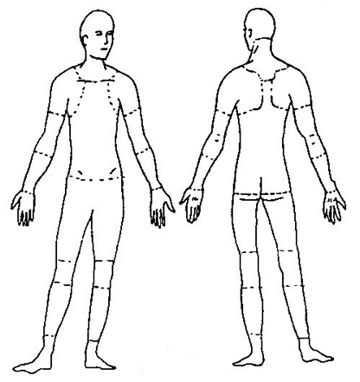 | Type of injury:  abrasion, scrapes  amputation  broken bone  bruise  burn (heat)  burn (chemical)  concussion (to the head) |  | crushing injury  cut, laceration, puncture  hernia  illness  sprain, strain  damage to a body system
 | other (give details below)
 | Was first aid administered? Yes No

If yes, by whom?

Was the injured person referred to the school nurse? Yes No

Additional Treatment Information:

WEATHER / ENVIRONMENTAL CONDITIONS (injured employee should complete this section with nurse’s assistance if needed)

(may include: temperature, housekeeping, lighting work surfaces, etc.)

DESCRIBE THE INCIDENT (injured employee should complete this section with nurse’s assistance if needed)

Exact location of the incident:
Incident occurred during what part of the employee’s workday?
entering or leaving work |  | doing normal work activities | during meal period
during break |  | working overtime | other
Names of witnesses (if any):

What personal protective equipment was being used?
Describe, step-by-step, the events that led up to the injury. Include names of machines, parts, objects, tools, materials, and any other important details.

POSSIBLE CAUSE(S) OF THE INCIDENT (injured employee’s supervisor should complete this section)

Unsafe workplace conditions (check all that apply)  inadequate guard  unguarded hazard  safety device is defective  tool or equipment defective  workstation layout is hazardous  unsafe lighting  unsafe ventilation  lack of proper personal footwear  lack of appropriate equipment / tools  unsafe clothing  wet surface  uneven surface  no training or insufficient training |  | Unsafe acts by people (check all that apply)  operating without permission  operating at unsafe speed  servicing equipment that has power to it  making a safety device inoperative  using defective equipment  using equipment in an unapproved way  unsafe lifting  taking an unsafe position or posture  distraction, teasing, horseplay  failure to wear personal protective equipment  spill not cleaned up  uneven surface not fixed  failure to use the available equipment / tools
other: |  | other:

Answer the following questions to the best of your knowledge.
Were unsafe acts or conditions reported prior to the incident? |  | Yes | No
Have there been similar incidents or near misses prior to this one? |  | Yes | No
Did employee receive specific training or instructions relating to safety on the job being performed? |  | Yes | No
If yes, what type of training? classroom video on the job (attach documentation)
Training was conducted by:

MACHINERY/EQUIPMENT (injured employee’s supervisor should complete this section if applicable)

Type of Machine: |  |  | Has machine/equipment been modified? | Yes | No
 |  |  | Was it properly guarded? | Yes | No
Location: |  |  | Was there any mechanical failure? | Yes | No

PREVENTING FUTURE INCIDENTS (injured employee’s supervisor should complete this section)

What changes do you suggest to prevent this incident/near miss from happening again? (select all that apply)
stop this activity |  | routinely inspect for hazard | train the employee(s) | train the supervisor(s)
redesign task steps |  | redesign work station | write new policy/rule | enforce existing policy
guard the hazard |  | personal protective equip | update policy/procedure | update/improve training
other:

What should be done to carry out above changes?

Form completed by: |  | Completed on:
NOTE: Please attach pertinent photos, diagrams, documentation, etc.

Employee Signature | Date |  | Administrative Supervisor’s Signature | Date

WORKPLACE SAFETY COMMITTEE USE ONLY

Recommendations of the Workplace Safety Committee:
Revised 7-2018

